API QUALIFIER
This questionnaire is designed to assess the suitability of all potential API connections to the I-REC(E) registry. Section I is mandatory for basic information and general requirements for all API requests. Whilst sections II and III expand into mandatory section for an accredited platform operator role with the I-TRACK Foundation. Sections III and IV will, following accreditation, become publicly available on I-TRACK Foundation’s website following your final approval of a public version of the report.

SECTION I: Basic Information
- Legal Name or Corporate Name (for the purpose of verification, information sharing and any future contractual arrangements).
(Legal name will typically be shown on the certificate of incorporation)
- Trading as (If required)
(N/A)
- Legally affiliated companies (If required).
(N/A)
- Secondary Consultants (Inc. Any outsourced technology resource).
(N/A)
- Main Contact Details
(Name/Role)
(Email addresses)
(Phone numbers)
- What role(s) does your organisation already have within the I-REC(E) Registry or Code?
☐ Registrant
☐ Participant
☐ Issuer
☐ Platform Operator
☐ Labelling Authority
☐ None
- What role(s) does your organisation wish to have within the I-REC(E) Registry or Code?

☐ Registrant
☐ Participant
☐ Issuer
☐ Platform Operator (Please complete all sections of this form)
☐ Labelling Authority
☐ Data Verifier (The process of becoming a Data Verifier requires a different questionnaire, please return to your Evident contact for further information)
☐ Other (Please explain): Click or tap here to enter text.
- Briefly describe what it is that you want your API connection to do?
E.g., As a Platform Operator,
I want to request and receive certificates issued for validated production data via the API,
So that I can allocate certificates to clients or corporate end-users in near real time.

E.g., As a Participant,
I want to submit a redemption request via the API for a client with full usage details,
So that I can support corporate sustainability claims and provide usage reports.

Please see fee structures for API limits.
- Are your prospective clients existing Evident registry users or are you going to act as an intermediary on their behalf?
E.g., Existing users, Intermediary for non-registry users, or Both

- How will your API integration benefit your prospective clients?
E.g., Internal use only: internal staff performing actions on behalf of your clients
E.g., External use: self-service system for your clients, i.e. clients will have their own logins to perform actions
Other: please describe

- Is your organisation formally accredited by a recognised standards body (e.g., ISO 27001, ISO 14065, CDP)?
(If Yes, please provide details: ………………….)

- Have you previously worked with other REC Registries, Guarantee of Origin (GO) systems, or other Renewable Energy Certificate (REC) markets?
(If Yes, please specify: ………………….)

- What security measures are implemented within the API to ensure data integrity and protect against unauthorised access or manipulation?
[Please describe: ………………….]

- Can you provide a system workflow or other diagramming to help us understand your requirements?
[Please provide: ………………….]

If your platform allows entities to request issuance, please answer questions 15 and 16 also:

- Can you confirm the number of facilities (inc. the average capacity of each) under contract with energy producers or buyers?
[If applicable, please explain: ………………….]

- What countries do your contracted facilities operate in or what countries do you wish to operate in?
[Please List: ………………….]

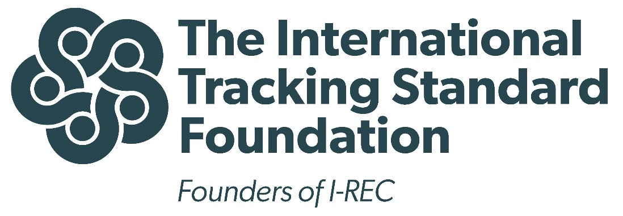

Preliminary report for integration with evident registry
[Name platform] Platform owned by [legal owner platform]
2025

Notice from the I-TRACK Foundation
This report has been completed by a Platform Operator and is a disclosure form, required by the I-TRACK Foundation, to inform potential users about the functioning of the operator’s Platform and its interaction with an Accredited Registry (Evident’s Registry).
Potential and existing Platform users are to be informed that there are different ways to access I-REC(E) and participate in the market. Every I-REC(E) is validated by accredited Issuers and ownership records are maintained on the Evident I-REC(E) Registry. Throughout the lifecycle of an I-REC(E) certificate, from issuance to eventual redemption, the certificate ownership is determined and recorded in the I-REC(E) Registry. The Registry also provides basic functionalities including device registration, I-REC(E) transfers and I-REC(E) redemptions. These services are accessible to anyone who is registered in the Registry and can also be accessed through existing market players (e.g., Registrants and Participants) who are familiar with the rules and requirements of the International Attribute Tracking Standard and associated I-REC(E) Product Code. However, the Registry can also be indirectly accessed via Accredited Platforms. These Platforms may provide different services, visualizations or tools which supplement the functionality provided by the Registry. However, use of a Platform is never mandatory for the issuance, trade, or redemption of I-REC(E). Users should, as a result, be informed of the Platforms they intend to make use of and determine if a Platform provides added value for them.
The I-TRACK Foundation and Evident periodically check that the Platform is adherent to the rules of Accreditation and well-integrated with the Registry. However, the Foundation, Evident Services or any Accredited Market Facilitator cannot be held responsible for the quality of services provided by Platform Operators.
If you have any further questions about the interaction between Platforms and the Evident Registry, please contact the I-TRACK Foundation secretariat at secretariat@trackingstandard.org.

SECTION II: Basic Information (Mandatory for prospective Platform Operators)

- Provide a short description of the purpose of the Platform.
E.g., what problem do you intend to solve
- Please define the primary markets or jurisdictions in which the platform will operate.
E.g., Brazil, India, or all I-REC(E) markets

- What languages does the Platform support?
E.g., English, Chinese,

SECTION III: Registration and client contact
- Please define the intended steps for various users of the Platform to be registered with the Platform Operator prior to use. Are legal agreements required? If so, are these prepared? If so, please include a link to the template agreement.
[Please define: ………………….]

- How can users access the Platform and who can they contact for questions?
[Please describe: ………………….]

- Please provide a description of the fees associated with the use of the Platform (e.g., link to fee structure).
[Please describe: ………………….]

SECTION IV: Detailed content
- Who can use your platform? (more than one is possible)
☐ Registrants registered in the Evident Registry
Ticking this box means that active Registrants in the Evident Registry can request facility registration and issuance requests with the responsible Issuer directly from the Platform.
☐ Participants registered in the Evident Registry
Ticking this box means that active Participants can have an encumbrance account in the Platform
☐ Any Entity, regardless of its relationship with the Evident Registry
Ticking this box means that any entity passing the requirements of the Platform can create an account and benefit from the provided services of the Platform that will be linked with the Platform’s custodian account in the Evident Registry.
- Please describe in detail the functionality of your Platform.
[Please describe: ………………….]

- How does the above functionality relate to the Accredited Registry (Evident’s Registry)? Include at least an answer to the two questions below.
1) Please explain whether you work with a custodian account, encumbrance, or both.
2) Please explain which of the following actions on the Evident Registry can be initiated from your Platform; request device registration, request issuance, withdraw I-RECs (from your platform to other platform or Participant account), Redeem I-RECs
[Please explain: ………………….]

- Who is the owner of the I-REC(E) at any point in the life cycle?
It is assumed to be the user who holds the I-REC(E) in your platform until the point of redemption where the ownership will be the entity listed as the beneficiary, without further opportunity to pass on that ownership anymore.
[Please describe: ………………….]

- Which of the following best describe your platform (more than one are possible):
☐ Market, trade, or exchange functionality
☐ Facilitation of Redemptions and/or creation of Platform Redemption statements
☐ Visualization tool or creation of reports on usage
☐ Mechanism to support increased granularity
☐ Mechanism to support registration of small or distributed devices
☐ Platform to simplify the issuance process
☐ Platform only for internal use (back-office/mid-office use)
☐ Other, namely: Click or tap here to enter text.
- In the situation that the platform has a market, trade, or exchange functionality, has an agreement with an associated financial institution been discussed? Are there expectations as to the needs for associated collateral?
[Please describe: ………………….]

- Will you market your product as I-REC(E) on the Platform?
☐ Yes
☐ No
If ‘No’, this should be discussed in detail with the I-TRACK Foundation. The creation of another tradable instrument (by tokenization, for example) is, by default, forbidden.
- Does your platform work on a blockchain? If so, do you intend to communicate benefits related of this externally? If so, how?
The I-TRACK Foundation is agnostic towards the use of a centralized or decentralized database. However, we remain critical towards unproven benefits such as the prevention of double counting in the wider I-REC(E) market. We encourage Platform Operators to discuss this with the I-TRACK Foundation.
[Please describe: ………………….]

- Are there other Products on your Platform (e.g., other EACs, carbon credits)? If so, how are the different Products marketed? Will it be clear for users of your Platform which Product they purchase with each transaction?
[Please describe: ………………….]

- In case certificates can be redeemed directly on the Platform, please provide a screenshot of the template Redemption Statement users can expect when using this redemption service on the Platform.
Platform Operators shall use the redemption statement created on the Evident Registry, or at minimum, copy the QR code, verification key, I-TRACK Foundation’s logo, and Evident’s logo from the original statement.
[Please provide screenshots: ………………….]

- What design elements have been considered to ensure that live, tradable certificates cannot be perceived as being owned or redeemed by an End-User prior to the act of redemption?
[Please describe: ………………….]

- Where can users find more information about the Platform? (e.g., links to documentation)
[Please describe: ………………….]

A registrant is the only entity that is able to request device registration or certificate issuance. They can do this on behalf of a device owner or on their own behalf (if they themselves are device owners).
A participant is a market player, trader or potentially a consumer with an account in Evident Registry and can hold, sell, buy, and redeem I-REC(E)s on their on behalf or on behalf of their clients.

